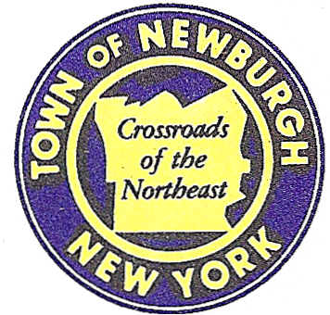

TOWN OF NEWBURGH
_______Crossroads of the Northeast __________________________
OLD TOWN HALL
308 GARDNERTOWN ROAD NEWBURGH, NEW YORK 12550

PLANNING BOARD
JOHN P. EWASUTYN, CHAIRMAN
TELEPHONE 845-564-7804
FAX 845-564-7802
E-MAIL: planningboard@townofnewburgh.org

PLANNING BOARD AGENDA

October 20th, 2016

*PLEASE NOTE: The Planning Board Meeting will start at 7:00 P.M. and all Applicants/Representatives
are to be present at that time. The Meeting will be held in the Meeting Room of Town Hall,
located at 1496 Route 300, Newburgh NY.*

1. Matrix (15-26) AMENDED SITE PLAN
Route 17K
Section 95, Block 1, Lot TBD
(portion of prior Lots 4.12, 54.1, 69.25 & 49.12)
Zone: IB
Rep: Langan Engineering, Environmental,
Surveying & Landscape Architecture
707 Westchester Ave, Suite 304
White Plains, NY 10604

2. Newburgh Bracesetters (16-18) INITIAL APPEARANCE
4 Spring Square Business Park AMENDED SITE PLAN
Section 63, Block 3, Lot 3
Zone: B
Rep: John Stoeckel ,P.E.
Maser Consulting
555 Hudson Valley Ave. Suite 101
New Windsor, NY 12553

*WORK SESSION*
Project Readiness Discussion scheduled for 5:30 p.m. in the Meeting Room of
Town Hall on Thursday, October 20th, 2016.*

PLANNING BOARD BUSINESS
WORK SESSION

1. Pet Hotel & Day Care (12-19) Refer to Work Session.
2. Elm Farm (00-9 ) 6 month extension from October 20, 2016 to April 20, 2017.

*WORK SESSION*
Project Readiness Discussion scheduled for 5:30 p.m. in the Meeting Room of
Town Hall on Thursday, October 20th, 2016.*

